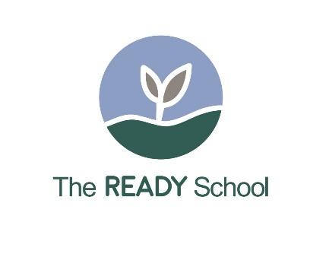

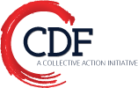
The Norcross READY School™
(Realizing the Early Achievement and Development of our Young)
An Early Learning & Family/Community Engagement Program

The Norcross READY School™, a play and learn program, provides early learning and school transition activities for 3 and 4 year- old Latino children and their families in an apartment complex located in Norcross, Georgia. The Norcross READY School™, formerly The La Escuelita (The Little School), was the brainstorm of Parents as Teachers (PAT) parents and informal caregivers. The families presented The Little School idea at a PAT group meeting held at the Rockbridge Apartments, Norcross, in 2004.
The families had a dream; they wanted early learning and group socialization experiences for their 3 and 4 year-old children to help prepare them for Georgia’s Pre-K and ultimately for their formal education, along with bi-lingual teachers and family resources to create a strong community through activities and leadership. Using the families’ ideas as the framework, the PAT Coordinator, Clara Herrera, and Roberta Malavenda, United Way consultant, worked with United Way in Gwinnett, along with a nearby early learning program, the American Learning Academy, and submitted a successful proposal to Primerica Citicorp Foundation, the first funder of The Little School in 2004.

Fast forward Fourteen Years Later…….

The Norcross READY School™ is currently located in the Crestwood Apartments and offers half-day sessions, serving approximately 80 children per year. The Norcross READY School™ program is operated by the American Learning Academy and provides free, culturally relevant early learning experiences for Spanish speaking 3 and 4 year-old children and their families. The children participate in activities to strengthen their social, emotional, and cognitive skills, and to help them transition into Georgia’s Pre-K program and/or to school. Families receive additional information and activities to be used at home with their children and participate in Friday family workshop and leadership activities. READY School teachers recently spent time observing in Reggio Emilia programs and are receiving ongoing coaching on the approach.
Every child is screened twice during the year using The Ages and Stages Questionnaire (ASQ-3). The current bi-lingual lead teacher is a former Little School parent, who received her CDA credentials, and is on the staff of the American Learning Academy. The majority of The Norcross READY School™ students transition into The American Learning Academy’s Georgia Pre-K program, with most attending the new DECAL summer transition program prior to Georgia Pre-K entry. The American Learning Academy has a strong relationship with the two local elementary schools.

Roberta Malavenda, Executive Director for CDF Action, provides the management, technical assistance, resources, and fund development for The READY School™ programs. CDF Action is the fiscal agent and umbrella agency which directs and oversees The READY School™ Initiative. Funding for The READY School™ is through the United Way of Greater Atlanta, with additional resources provided by DECAL and other community partners. Clara Herrera, a founder of The Little School in 2004, continues to provide consultation and coordination with the American Learning Academy, along with community resources. The Norcross READY School™ serves as a learning laboratory for other communities interested in learning more about The READY School™ Initiative.

For additional program information or how to set up a READY School™ in your community, please contact:
Roberta Malavenda, Executive Director, CDF Action, roberta@cdfaction.org
www.cdfaction.org

