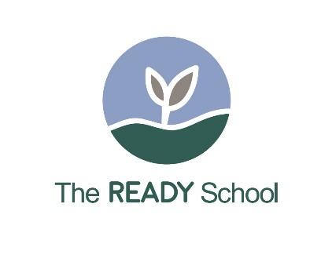

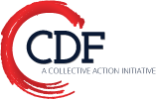
The Clarkston Oaks READY School™
(Realizing the Early Achievement and Development of our Young)
An Early Learning & Family/Community Engagement Program

The Clarkston Oaks READY School™, a play and learn program, provides early learning and school transition activities for 3 and 4 year- old refugee children and their families in an apartment complex located in Clarkston, Georgia. The Clarkston Oaks READY School™, was the brainstorm of Arabic-speaking families who attended a CDF Action Early Learning Community Trust Dialogue in 2015 As a result of meetings with families, the apartment complex management, City of Clarkston, and Early Learning Property Management, and with funding from United Way, the Clarkston Oaks READY School was born.
The Clarkston Oaks READY School is located in space renovated by the R James Property Managers, owners of the apartment complex. The program is based in large part on the model developed in Norcross, La Escuelita, and adapted to the refugee families in Clarkston.
The Clarkston Oaks READY School, serving children in the year before Georgia Pre-Kindergarten, is operated by Scottdale Early Learning, a nationally accredited, quality rated early learning center, through a sub-contract with CDF Action. CDF serves as the fiscal agent and provides oversight, technical assistance, report writing, and mobilizes additional resources for the program.
READY School children arrive at 9 a.m. and the program ends at 12 noon, Monday through Thursday. There are two cohorts – one group attends Monday and Wednesday and a second group attended Tuesday and Thursday, 7 children per cohort. The program follows a daily schedule, is aligned with the Georgia Department of Early Learning standards, and uses the Creative Curriculum.
The children participate in activities to strengthen their social, emotional, and cognitive skills and to help them transition into Georgia’s Pre-K program. Each child is screened using the Ages and Stages Questionnaire (ASQ-3). Families receive additional information and activities to be used at home with their children and participate in family workshops and leadership activities. A major objective of the program is to engage the families in the child’s early learning and to help identify, enroll, and transition the child into a Georgia Pre-Kindergarten program. Many of the children participate in summer Pre-K transition programs offered by Scottdale and the schools.
The children and their families are primarily from Iraq, Burma, Bhutan, Syria, Somalia, and Afghanistan. The program has served as a practicum site for multi-lingual Child Development Associate (CDA) candidates, and the current teachers, who are on the staff of Scottdale Early Learning, have or are working on their CDA credential. The lead teacher from Iraq taught kindergarten in her home country. Interns from Emory University have shared their time and talents with the children.
Since the beginning of the program, the Clarkston READY School has served 80 children, with over 75 percent transitioning into a Georgia Pre-K program, including programs operated by Scottdale Early Learning, other child care centers, and the schools.

The READY School provides a warm and welcoming environment, with indoor and outdoor activities. Visitors are invited and you are certain to see books and hear joyful language and songs in multiple languages.

For additional program information or how to set up a READY School™ in your community, please contact:
Roberta Malavenda, Executive Director, CDF Action, roberta@cdfaction.org
www.cdfaction.org

